Warm Up

# Analyzing Core Mechanics of a Video Game

**Instructions**:

1. Look at the picture of the popular video game displayed on the board.

2. Individually, identify and write down the core mechanics of the game.

3. After a few minutes, share your answers with a partner or in small groups.

4. Discuss and compare your answers with your partner/group.

5. Be prepared to share your findings with the class.

Game Picture:



Core Mechanics:

1. _______________________

2. _______________________

3. _______________________

4. _______________________

5. _______________________

Example Answers:

Game Picture:

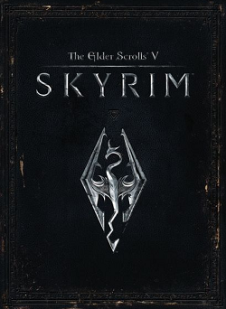

Core Mechanics:

1. Exploration: The game allows players to explore a vast open world, uncovering new locations, and discovering hidden treasures.

2. Combat: Players engage in battles with enemies using various weapons and abilities to defeat them.

3. Quests/Objectives: The game presents players with quests or objectives to complete, which often involve solving puzzles, finding items, or defeating specific enemies.

4. Character Progression: Players can level up their character, acquire new skills, and improve their abilities as they progress through the game.